DUWEM GRANT PROPOSAL
Building Africa's First Web3 Social Commerce Ecosystem
Funding Request: US$25,000
Funding Duration: 6 Months

Executive Summary
The way people discover products, make purchasing decisions, and engage with brands has evolved significantly over the last decade. Commerce is no longer driven solely by product listings and advertisements; it is increasingly shaped by communities, creators, reviews, recommendations, and social interactions. Every day, consumers influence purchasing decisions, creators build trust, and communities generate engagement that drives business growth. Yet despite their contributions, the individuals and businesses that create much of this value rarely share in the economic benefits generated by the digital platforms they help sustain.
DUWEM is building Africa's first Web3-powered social commerce ecosystem where every merchant and brand can establish a branded digital storefront that reflects their business identity while enabling consumers, creators, and communities to actively participate in the value they help create. Rather than functioning as a traditional online marketplace, DUWEM integrates commerce, community engagement, reputation, and blockchain-powered incentives into a unified ecosystem where businesses cultivate loyal communities, creators influence purchasing decisions, and consumers become active participants rather than passive buyers.
At the core of the platform is a reputation-first framework that recognizes trust, credibility, and meaningful contribution before economic rewards. Businesses grow through community engagement and trusted relationships, consumers build reputation through verified participation, and creators are rewarded for generating measurable value within the ecosystem. The platform's native utility token, DWM, supports governance participation, merchant incentives, creator monetization, referrals, ecosystem rewards, and premium platform services while reinforcing long-term ecosystem sustainability.
This grant will support the validation phase of DUWEM, including market research, stakeholder engagement, prototype development, merchant onboarding, community building, and refinement of the platform's technical architecture and token economy. The objective is to validate a scalable model for community-driven digital commerce that lowers the barriers to Web3 adoption by embedding blockchain technology into familiar commercial experiences. Through this approach, DUWEM aims to establish the foundation for a new generation of digital commerce where businesses, consumers, creators, and communities grow together and share more equitably in the value they collectively create.

Founding Team
DUWEM is led by a founding team committed to exploring how social commerce, community participation, and blockchain technology can be combined to create more inclusive digital economies. The team brings together complementary strengths in product vision, ecosystem development, business strategy, and stakeholder engagement, with a shared focus on building practical Web3 solutions that solve real-world problems.
Cosmas Udom: Founder & Product Strategy Lead
Cosmas Udom is the founder of DUWEM and leads the project's vision, product strategy, ecosystem design, and long-term growth planning. He is responsible for identifying market opportunities, defining the platform's value proposition, coordinating validation activities, and ensuring that product development remains aligned with user needs and ecosystem objectives. His focus is on building accessible technology solutions that enable broader participation in digital commerce and Web3 innovation.
Atanganam Paulinus: Co-Founder & Business Development Lead
Atanganam Paulinus serves as Co-Founder and leads business development, partnership engagement, merchant outreach, and operational planning. He is responsible for building relationships with merchants, community stakeholders, and strategic partners while helping to shape the platform's market adoption strategy. His role focuses on ensuring that DUWEM remains closely connected to the needs of businesses, creators, and consumers throughout the validation and growth phases.
Together, the founding team is committed to validating the DUWEM concept, building meaningful ecosystem partnerships, and establishing the foundation for a sustainable social commerce infrastructure capable of driving broader Web3 adoption through every-day commercial activity.
Progress to Date
Prior to this funding request, the DUWEM team has independently invested significant time and effort into validating the project's core assumptions and refining its strategic direction. This work demonstrates the team's commitment to building the platform responsibly and reducing execution risk before seeking external funding.
Initial progress includes the development of a comprehensive product vision, high-fidelity UI/UX designs, a modular platform architecture, merchant and consumer validation surveys, stakeholder engagement materials, a waitlist strategy, and supporting documentation covering token utility, governance, and ecosystem design. These activities demonstrate the team's commitment to validating the concept and reducing execution risk before requesting grant support. It also established a strong foundation for the project's next stage of development.
The requested funding will build upon this progress by supporting prototype refinement, technical readiness, ecosystem expansion, product validation, and the preparation required to transition confidently toward MVP development.
Problem Statement
The digital economy has transformed how people shop, interact, and create value online, yet the benefits of this transformation remain concentrated among a small number of platform owners. Every day, consumers influence purchasing decisions through reviews, referrals, recommendations, and social engagement, while merchants invest significant resources into acquiring and retaining customers. Creators and community leaders drive conversations, build trust, and generate attention that fuels commerce. Despite these contributions, the individuals and businesses that create much of the value within digital ecosystems rarely share in the economic upside they help generate.
At the same time, social commerce continues to grow as consumers increasingly rely on communities, influencers, and peer recommendations when making purchasing decisions. However, existing platforms separate commerce, community, and rewards into disconnected experiences that fail to create lasting value for participants. While blockchain technology offers the potential to enable ownership, transparency, and incentive alignment, many existing Web3 applications remain inaccessible to mainstream users and are often driven more by speculation than practical utility.
In addition, many businesses struggle to establish a unified digital presence that truly reflects their brand and strengthens long-term customer relationships. Their products, conversations, communities, reviews, and customer interactions are often spread across multiple disconnected platforms, making it difficult to build lasting trust and loyalty. Rather than operating from a single branded digital destination where commerce, community, and customer relationships reinforce one another, merchants are forced to manage fragmented online experiences that limit engagement, weaken customer loyalty, and reduce opportunities for sustainable growth.
This creates a significant opportunity to build a new type of platform that combines commerce, community engagement, reputation, and meaningful rewards into a unified ecosystem. Such a platform can empower merchants to establish branded digital storefronts, enable consumers, creators, and communities to participate more actively in value creation, and create a more transparent and collaborative digital economy where trust, reputation, and meaningful contribution are recognized and rewarded.
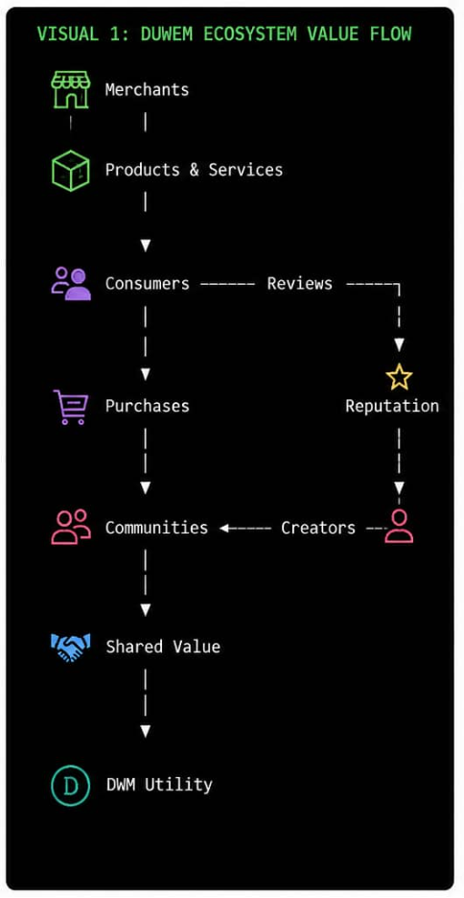

Why Now?
The convergence of social commerce, the creator economy, and maturing blockchain infrastructure present a unique opportunity to redefine how digital commerce is experienced and how value is created and distributed online. Consumers increasingly rely on recommendations, communities, and trusted creators when making purchasing decisions, while merchants seek more efficient ways to build loyalty and acquire customers. At the same time, blockchain infrastructure has matured to a point where it can support scalable consumer applications with lower costs and improved user experiences.
In addition, businesses are increasingly seeking greater ownership of their digital presence and customer relationships. Rather than relying solely on fragmented social media profiles or third-party marketplaces, merchants are looking for integrated digital experiences that strengthen their brand identity, foster community engagement, and build long-term customer loyalty. This shift creates a timely opportunity for platforms that combine commerce, community, and trust within a unified ecosystem.
This convergence creates a timely opportunity for DUWEM to bridge commerce, community, and trust through branded digital storefronts while introducing mainstream users to Web3 through practical, everyday interactions rather than speculative use cases.
Why DUWEM?
DUWEM is not simply another online marketplace or Web3 application. It is designed as a new model for digital commerce that brings together branded digital storefronts, social commerce, and reputation-driven value creation within a single integrated ecosystem.
Unlike traditional marketplaces where merchants compete primarily through product listings, DUWEM enables every business to establish a branded digital storefront that reflects its identity, products, community, and customer relationships. Rather than treating commerce as a series of isolated transactions, the platform encourages merchants to cultivate long-term relationships with consumers through engagement, trust, and community participation.
Beyond commerce, DUWEM recognizes that creators, consumers, and communities contribute significant value through product discovery, referrals, reviews, educational content, and ongoing engagement. By combining a reputation-first framework with carefully designed blockchain-powered incentives, the platform aligns the interests of all participants while encouraging meaningful contribution over short-term engagement.
This integrated approach positions DUWEM not only as a commerce platform, but as a digital ecosystem where businesses build communities, communities influence commerce, and value is shared more equitably among those who help create it.
Proposed Solution
DUWEM is a Web3-powered social commerce ecosystem designed to reimagine how businesses, consumers, creators, and communities interact within the digital economy. Rather than functioning as a conventional online marketplace, DUWEM enables every merchant and brand to establish a customizable digital storefront that reflects their unique identity, products, reputation, and customer relationships. Each storefront serves not only as a place to buy and sell products, but also as a hub for community engagement, content discovery, customer interaction, and long-term relationship building.
Built around these branded digital storefronts, DUWEM integrates commerce, social networking, reputation, and blockchain-powered incentives into a single ecosystem. Consumers can discover products, interact with merchants, participate in discussions, share recommendations, leave verified reviews, and build trusted relationships within communities. Merchants gain more than a digital sales channel—they gain the tools to cultivate loyal communities, strengthen customer relationships, increase visibility through reputation, and grow their businesses through meaningful engagement rather than transactional interactions alone. Creators are empowered to monetize their influence through referrals, product promotion, educational content, and community leadership, creating new opportunities to participate in digital commerce.
At the heart of the platform is a reputation-first framework that recognizes trust, credibility, and meaningful contribution before economic rewards. Users build reputation through verified purchases, quality reviews, successful referrals, helpful contributions, and positive community participation. This reputation system becomes the foundation for recognition, trust, access to ecosystem benefits, and the responsible distribution of rewards, encouraging long-term value creation while reducing the risk of low-quality or abusive behavior.
Supporting this ecosystem is the DUWEM Token (DWM), a utility asset designed to facilitate participation rather than speculation. The token enables ecosystem rewards, governance participation, merchant incentives, creator monetization, premium platform services, advertising, and community initiatives while reinforcing the alignment of incentives among stakeholders. By ensuring that rewards are tied to meaningful participation and ecosystem growth, DUWEM promotes a sustainable digital economy where value circulates among those who help create it.
Blockchain technology serves as the trust infrastructure that underpins the ecosystem while remaining largely invisible to everyday users. It enables transparent reward distribution, verifiable reputation mechanisms, governance participation, digital ownership, and secure ecosystem interactions without introducing unnecessary complexity into the user experience. This approach allows users to experience the benefits of decentralization through familiar activities such as shopping, reviewing products, participating in communities, supporting merchants, and earning rewards.
DUWEM's ecosystem is built around a continuous value exchange model in which merchants, consumers, creators, and communities each contribute to and benefit from platform growth. Merchants create value by offering products, services, and customer experiences through their branded digital storefronts. Consumers create value through purchases, referrals, reviews, and community participation. Creators contribute by increasing product discovery, building trust, educating audiences, and strengthening communities. As commercial activity grows, value is reinvested through rewards, platform improvements, ecosystem initiatives, and community development, creating a sustainable cycle that aligns incentives across all participants.
The initial validation phase will focus on refining the platform's design, validating market demand, developing a high-fidelity interactive prototype, engaging merchants and community members, validating the branded storefront model, and establishing the technical and economic foundations required to support future MVP development and ecosystem growth.
Innovation
DUWEM introduces a new model for digital commerce by integrating three traditionally separate experiences—merchant identity, social commerce, and value distribution—into a single, reputation-driven ecosystem. Rather than improving one aspect of existing online marketplaces, the platform reimagines how businesses, consumers, creators, and communities interact and create value together.
The first innovation is the introduction of branded digital storefronts, where every merchant or brand establishes a persistent digital presence that reflects its identity, products, reputation, community, and customer relationships. Instead of relying on fragmented marketplace listings and disconnected social media profiles, businesses operate from a unified digital destination where commerce and engagement reinforce one another.
The second innovation is the integration of social commerce as a core platform function rather than an external marketing channel. Consumers, creators, and communities actively influence product discovery through reviews, referrals, educational content, discussions, and trusted recommendations, transforming commerce from a transactional experience into a collaborative ecosystem built on participation and trust.
The third innovation is DUWEM's reputation-first value model, which prioritizes trust, credibility, and meaningful contribution before economic incentives. Reputation is earned through verified purchases, quality reviews, successful referrals, helpful participation, and positive community engagement. Blockchain technology then enables transparent reward distribution, governance participation, and digital ownership while remaining largely invisible to users, allowing them to benefit from decentralized infrastructure without the complexity often associated with Web3 applications.
By combining these three pillars within a unified platform, DUWEM creates an ecosystem where businesses build communities, communities strengthen businesses, and meaningful contributions are recognized through reputation and shared value creation. This integrated approach distinguishes DUWEM from traditional e-commerce platforms, social media networks, and standalone Web3 applications, positioning it as a practical pathway for mainstream adoption of decentralized technologies through everyday commerce.
DUWEM's innovation is not the introduction of a single new technology, but the integration of proven technologies and behavioral models into a unified ecosystem that aligns the incentives of businesses, consumers, creators, and communities.
Competitive Landscape
The digital commerce ecosystem consists of several categories of platforms that each address different aspects of online buying, selling, and community engagement. Traditional e-commerce platforms provide merchants with tools to sell products online and manage transactions, while social media platforms excel at content discovery, audience engagement, and community building. At the same time, emerging Web3 applications introduce decentralized ownership, tokenized incentives, and community governance. Although each of these models delivers meaningful value, they generally operate as separate experiences that require users and businesses to navigate multiple disconnected platforms.
For merchants, this often means maintaining independent websites or marketplace listings, managing multiple social media accounts, coordinating creator collaborations, and operating separate customer engagement channels. Consumers, creators, and communities likewise participate across fragmented ecosystems where commerce, conversation, reputation, and rewards are rarely integrated into a single experience.
DUWEM is positioned differently. Rather than competing on individual features, the platform combines three complementary pillars within one integrated ecosystem. First, every merchant and brand can establish a branded digital storefront that serves as a unified destination for products, customer engagement, and community building. Second, social commerce capabilities enable consumers, creators, and communities to influence product discovery through discussions, referrals, reviews, educational content, and trusted recommendations. Third, a reputation-first incentive model supported by blockchain technology recognizes meaningful contribution and enables participants to share in the value they help create.
This integrated approach allows DUWEM to bridge the gap between traditional commerce, social engagement, and decentralized participation. Instead of asking businesses and users to move between disconnected platforms, DUWEM creates a unified environment where commerce, community, reputation, and shared value reinforce one another. This positioning enables the platform to deliver a differentiated user experience while supporting broader Web3 adoption through familiar commercial activities rather than purely speculative use cases.
Our competitive landscape is illustrated in the table below:
Feature | Traditional E-Commerce | Social Platform | Web3 Marketplace | DUWEM
Branded Digital Storefronts | ✓ | ✗ | Partial | ✓
Community Engagement | Limited | ✓ | Partial | ✓
Product Discovery | ✓ | ✓ | Limited | ✓
Reputation-First System | Limited | Limited | Partial | ✓
Creator Collaboration | Limited | ✓ | Partial | ✓
Shared Value & Rewards | ✗ | ✗ | ✓ | ✓
Creator Monetization | Limited | ✓ | Partial | ✓
Blockchain Incentive | ✗ | ✗ | ✓ | ✓
Governance Participation | ✗ | ✗ | ✓ | ✓
Web3 Hidden Behind Familiar UX | ✓ | ✓ | Limited | ✓

Target Market
DUWEM is designed as a multi-sided ecosystem that serves four interconnected stakeholder groups: merchants, consumers, creators, and communities. While each group derives unique value from the platform, their interactions collectively drive network growth, trust, and long-term ecosystem sustainability.
The initial validation phase will focus primarily on small and medium-sized businesses (SMBs), emerging brands, and digital entrepreneurs seeking stronger customer relationships and a unified online presence through branded digital storefronts. These businesses often rely on fragmented combinations of physical stores, social media platforms, messaging applications, and online marketplaces to engage customers, creating significant opportunities for a more integrated commerce experience.
Alongside merchant onboarding, DUWEM will engage consumers who actively discover products through recommendations, reviews, referrals, and community interactions. The platform will also support creators who influence purchasing decisions through educational content and trusted recommendations, as well as communities that foster engagement, discussion, and long-term customer loyalty.
Nigeria has been selected as DUWEM's initial validation market because of its rapidly growing digital economy, vibrant entrepreneurial ecosystem, expanding creator economy, widespread social commerce behavior, and increasing adoption of mobile technology and digital payments. These characteristics provide an ideal environment for validating the platform's core assumptions before expanding into other African markets and, ultimately, broader international markets.
By validating the interaction between merchants, consumers, creators, and communities within a single ecosystem, DUWEM aims to establish a scalable model for community-driven digital commerce that can be replicated across emerging and developed markets alike.
Technical Architecture
DUWEM is being designed as a modular, scalable social commerce ecosystem capable of supporting both familiar consumer experiences and blockchain-powered functionality. The architecture prioritizes usability, performance, security, and long-term scalability while ensuring that decentralized technologies enhance the user experience rather than complicate it.
At the core of the platform is a Branded Digital Storefront Module, which enables every merchant and brand to establish a customizable digital presence that reflects its identity, products, reputation, customer relationships, and community. Rather than functioning as a simple product listing, each storefront serves as a dynamic commercial hub where transactions, engagement, and trust are built over time.
Supporting the storefront layer is a Social Commerce Module that facilitates product discovery through reviews, referrals, discussions, creator content, community interactions, and personalized recommendations. This module is designed to strengthen customer engagement and transform commerce into a collaborative, community-driven experience.
The platform also incorporates a Reputation & Rewards Module, where users earn reputation through verified purchases, meaningful reviews, successful referrals, helpful contributions, and positive community participation. Reputation becomes the foundation for ecosystem recognition, while blockchain-powered reward mechanisms ensure that incentives are distributed transparently and fairly according to measurable contributions.
Behind these user-facing experiences, a modular backend infrastructure manages authentication, user profiles, marketplace operations, storefront management, inventory, analytics, search, notifications, messaging, community management, reputation calculations, and reward distribution. This modular design allows new services and capabilities to be introduced over time without disrupting the overall platform architecture.
Blockchain technology functions as the ecosystem's trust infrastructure rather than its primary user interface. Smart contracts will manage token-related activities, governance participation, staking mechanisms where applicable, digital ownership, and transparent reward distribution while remaining largely invisible to users who are unfamiliar with Web3 technologies. This approach enables DUWEM to deliver the benefits of decentralization through familiar shopping and social experiences without requiring users to understand the underlying blockchain infrastructure.
During the validation phase, DUWEM will evaluate blockchain infrastructure options based on scalability, transaction costs, security, developer tooling, ecosystem support, interoperability, and long-term sustainability. The platform is intentionally being designed with blockchain flexibility in mind, allowing it to integrate with mature ecosystems capable of supporting consumer-scale applications while remaining adaptable to future technological advancements.
Security, privacy, transparency, and scalability will remain foundational principles throughout development. Future implementation phases will include comprehensive smart contract audits, fraud detection systems, reputation integrity mechanisms, secure identity management, and governance infrastructure to support the long-term reliability, resilience, and growth of the DUWEM ecosystem.
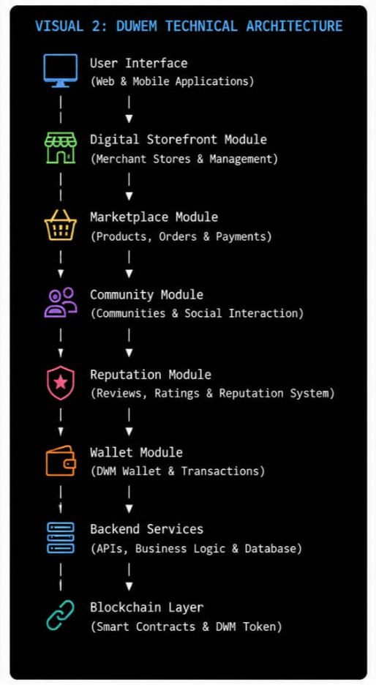
Token Model (DWM)
DUWEM adopts a reputation-first incentive model in which trust, credibility, and meaningful contribution form the foundation of ecosystem participation. Within this model, the DUWEM Token (DWM) functions as the platform's native utility asset, supporting ecosystem activities rather than serving as a speculative investment instrument.
The DWM token is designed to align incentives across merchants, consumers, creators, and communities by facilitating participation in the platform's economic and governance activities. Rather than rewarding every interaction indiscriminately, token incentives are distributed strategically to participants who demonstrate meaningful contributions through verified purchases, quality reviews, successful referrals, community engagement, creator activities, merchant growth, and other value-generating behaviors that strengthen the ecosystem.
For merchants, DWM enables ecosystem rewards, promotional campaigns, premium business services, advertising opportunities, and participation in community governance. Consumers may use the token to access premium features, receive ecosystem rewards, participate in governance, and engage in community-driven initiatives. Creators can earn DWM through verified campaigns, educational content, trusted recommendations, and community leadership, while communities may utilize the token to support collaborative initiatives, governance participation, and ecosystem development.
The relationship between reputation and rewards is central to DUWEM's economic model. Reputation is earned first through meaningful participation and verified contributions. As reputation grows, participants gain greater access to ecosystem opportunities, recognition, and strategic token-based incentives. This approach encourages sustainable engagement, discourages low-quality activity, and aligns rewards with long-term value creation rather than short-term engagement metrics.
As the ecosystem matures, DWM will also support decentralized governance, enabling stakeholders to participate in selected platform decisions and community initiatives. During the validation phase, the project will focus on refining the tokenomics framework, governance model, and utility mechanisms to ensure that the economic design supports long-term sustainability, responsible incentive alignment, and healthy ecosystem growth.
Validation Targets
To ensure that progress can be measured objectively throughout the validation phase, DUWEM has established a set of tangible milestones designed to validate the platform's core assumptions, demonstrate market demand, and reduce key execution risks before MVP development.
These validation targets assess the most critical dimensions of the ecosystem, including merchant demand, consumer interest, community participation, product desirability, technical readiness, and ecosystem engagement. Collectively, they provide measurable evidence that DUWEM's model of branded digital storefronts, community-driven commerce, reputation-first participation, and shared value creation addresses a genuine market need while establishing the foundations required for long-term platform development.
By the conclusion of the validation phase, DUWEM aims to achieve:
- 500+ qualified waitlist registrations from prospective users.
- 50+ merchant interviews and validation conversations completed.
- 20+ merchants committed to participating in future pilot testing activities.
- 200+ completed consumer survey responses validating shopping behavior, referral patterns, and reward preferences.
- 1,000+ engaged community members across ecosystem communication channels.
- One fully functional high-fidelity interactive prototype demonstrating the core user experience, including branded digital storefronts, social commerce features, and reputation mechanisms.
- A completed DWM token utility framework and supporting tokenomics model.
- A documented modular platform architecture, blockchain infrastructure assessment, and governance framework specification.
- Initial partnership discussions with ecosystem stakeholders, creators, merchants, and community leaders.
Collectively, these milestones will provide measurable evidence that DUWEM's value proposition resonates with its target stakeholders, that the platform's core assumptions have been validated, and that the technical and ecosystem foundations required for MVP development have been established.
By achieving these milestones, DUWEM will be well positioned to transition from concept validation to MVP development with significantly reduced execution risk, stronger evidence of market demand, and increased confidence from future partners, grant providers, and investors.
Development Roadmap
Prior to submitting this proposal, DUWEM is undertaking an initial validation process to reduce market uncertainty and strengthen the project's strategic direction. This includes merchant and consumer surveys, stakeholder interviews, waitlist generation, and early ecosystem engagement to validate demand for branded digital storefronts, community-driven commerce, and the platform's reputation-first value model. Insights gathered through these activities will directly inform product design, ecosystem strategy, and technical decision-making.
Building on this validated foundation, the current grant phase will focus on translating market insights into a high-fidelity interactive prototype that demonstrates DUWEM's core user experience, including branded digital storefronts, social commerce features, reputation mechanisms, and community engagement. The prototype will be refined through iterative feedback from prospective merchants, consumers, ecosystem partners, and other stakeholders.
The grant will also support the refinement of DUWEM's technical and economic foundations, including the modular platform architecture, DWM token utility model, governance framework, blockchain infrastructure evaluation, and smart contract specifications. These activities will establish the technical blueprint required for future MVP development while ensuring that the platform remains scalable, secure, and aligned with long-term sustainability objectives.
By the conclusion of the grant period, DUWEM aims to deliver a validated product concept supported by market evidence, a high-fidelity interactive prototype, a documented technical architecture, a refined tokenomics and governance framework, and a clear execution roadmap toward MVP development and pilot deployment.
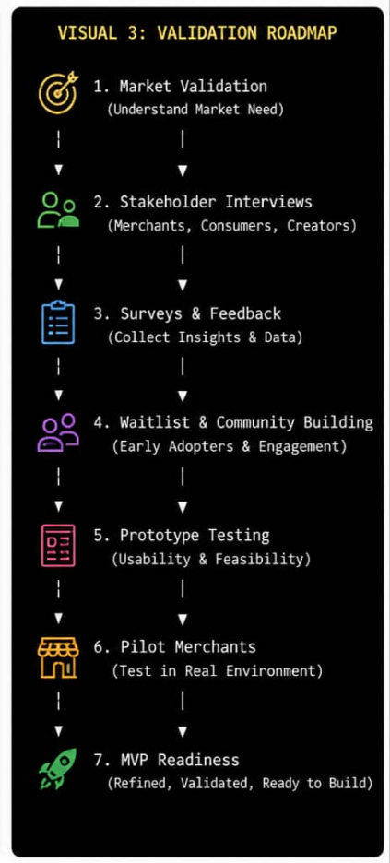
Success Metrics
The success of the validation phase will be measured through a combination of market, product, ecosystem, and technical validation outcomes. These metrics are designed to demonstrate that DUWEM has successfully reduced key uncertainties and established a strong foundation for MVP development.
Market Validation
- 500+ qualified waitlist registrations from prospective users.
- 50+ completed merchant interviews and validation conversations.
- 200+ consumer survey responses validating shopping behaviors, reward preferences, and community engagement.
- 20+ merchants expressing interest in participating in future pilot activities.
Product Validation
- Completion of a high-fidelity interactive prototype demonstrating DUWEM's core user experience.
- Positive qualitative feedback from merchants, consumers, and ecosystem stakeholders on the branded digital storefront concept, social commerce features, and reputation-first participation model.
- User validation confirming the clarity, usability, and perceived value of the proposed platform experience.
Ecosystem Validation
- Growth of an engaged community of at least 1,000 members across DUWEM communication channels.
- Initial engagement with creators, ecosystem partners, and community leaders interested in future collaboration.
- Evidence that the interaction between merchants, consumers, creators, and communities supports DUWEM's ecosystem model and value proposition.
Technical Readiness
- Completion of the modular platform architecture.
- Refined DWM token utility framework and governance model.
- Documented smart contract architecture and blockchain infrastructure assessment.
- A clear technical roadmap supporting future MVP development.
Collectively, these metrics will demonstrate that DUWEM has validated its market opportunity, strengthened its product strategy, reduced technical uncertainty, and established the ecosystem foundations necessary to progress confidently toward MVP development and pilot deployment.
Risks and Mitigation
As an early-stage Web3 social commerce project, DUWEM recognizes that successful execution requires careful management of technical, market, ecosystem, and regulatory risks. The project has therefore adopted a phased validation strategy designed to reduce uncertainty before significant development investment.
One of the primary risks is merchant adoption, as the long-term success of the ecosystem depends on attracting businesses willing to establish branded digital storefronts and engage with community-driven commerce. To mitigate this risk, DUWEM is conducting merchant interviews, validation surveys, waitlist campaigns, and stakeholder engagement activities to ensure that product development is guided by real market demand rather than assumptions.
A second risk involves consumer and community engagement. Building a sustainable social commerce ecosystem requires active participation from consumers, creators, and communities in addition to merchants. DUWEM addresses this through a reputation-first participation model, early community building, creator engagement, structured user validation, and iterative product design informed by continuous stakeholder feedback.
The project also recognizes the importance of designing a sustainable token economy. Incentive systems that prioritize short-term rewards over meaningful participation can encourage low-quality behavior and weaken ecosystem trust. DUWEM mitigates this risk by placing reputation ahead of token rewards, positioning the DWM token as a utility asset that supports governance, ecosystem participation, and long-term value creation rather than speculative activity.
From a technical perspective, integrating commerce, social networking, and blockchain technologies presents architectural complexity. DUWEM addresses this through a modular platform architecture, phased implementation, careful blockchain infrastructure evaluation, and future smart contract security audits to ensure scalability, reliability, and maintainability as the platform evolves.
Finally, the regulatory environment surrounding blockchain technologies continues to evolve across global markets. DUWEM will monitor relevant regulatory developments, design its token model around genuine platform utility, and adopt a flexible governance and compliance approach that allows the ecosystem to adapt to changing legal and regulatory requirements as it expands.
By identifying these risks early and incorporating mitigation strategies into the validation process, DUWEM seeks to build a resilient, user-centered, and sustainable ecosystem capable of supporting long-term growth and responsible innovation.
Expected Impact
DUWEM seeks to create a lasting impact by reimagining how businesses, consumers, creators, and communities participate in digital commerce. Rather than introducing another online marketplace, the platform aims to establish a collaborative ecosystem where commerce, community, reputation, and shared value reinforce one another, creating more sustainable and inclusive opportunities for all participants.
For businesses, DUWEM will enable merchants and brands to establish branded digital storefronts that strengthen their digital identity, deepen customer relationships, and cultivate loyal communities beyond traditional transactional commerce. By bringing commerce and community together within a single platform, merchants will be better positioned to improve customer engagement, increase trust, and build long-term business resilience.
For consumers, creators, and communities, DUWEM introduces a reputation-first model that recognizes meaningful participation through verified purchases, trusted recommendations, quality reviews, referrals, educational content, and community engagement. This approach encourages collaboration, promotes trust, and enables participants to contribute more actively to the growth of the ecosystem while benefiting from the value they help create.
At the ecosystem level, DUWEM demonstrates how blockchain technology can be applied to solve practical, everyday challenges rather than purely speculative use cases. By embedding decentralized infrastructure behind familiar shopping and social experiences, the platform lowers barriers to Web3 adoption while showcasing a sustainable model for incentive alignment, transparent participation, and digital ownership.
Beyond the platform itself, DUWEM has the potential to contribute to Africa's growing digital economy by empowering entrepreneurs, supporting small and medium-sized businesses, strengthening the creator economy, and encouraging greater participation in community-driven digital commerce. The platform's validation in Nigeria will provide a foundation for future expansion across African markets, demonstrating how locally developed innovation can address regional challenges while contributing to the broader evolution of the global digital economy.
By successfully validating its ecosystem model, DUWEM aims to establish a scalable foundation for a new generation of digital commerce where businesses build communities, communities strengthen businesses, and meaningful contributions are recognized through reputation, collaboration, and shared value creation.
Ecosystem Impact
DUWEM is designed to generate impact beyond the creation of a single digital platform by strengthening the broader digital commerce ecosystem. Through the integration of branded digital storefronts, social commerce, reputation-driven participation, and blockchain-powered utility, the project aims to demonstrate a more collaborative and sustainable model for digital commerce that benefits all ecosystem participants.
For merchants and brands, DUWEM provides an opportunity to establish unified digital storefronts that strengthen their online identity, deepen customer relationships, and build communities around their businesses rather than relying solely on fragmented social media channels or third-party marketplaces. This approach supports long-term business growth through trust, engagement, and customer loyalty.
For consumers, creators, and communities, the platform creates new opportunities to contribute meaningfully to commerce through reviews, referrals, educational content, recommendations, and community participation. By recognizing these contributions through a reputation-first framework and carefully designed utility incentives, DUWEM encourages higher-quality engagement while fostering trust and collaboration across the ecosystem.
At the ecosystem level, DUWEM demonstrates how blockchain technology can move beyond speculative applications to support practical, everyday commercial experiences. By embedding decentralized infrastructure within familiar shopping and community interactions, the platform lowers barriers to Web3 adoption and illustrates how blockchain can enhance transparency, participation, digital ownership, and incentive alignment without increasing complexity for end users.
The project also contributes to the broader innovation ecosystem by creating opportunities for collaboration among entrepreneurs, merchants, creators, developers, community leaders, and ecosystem partners. Through open engagement, stakeholder feedback, and responsible innovation, DUWEM seeks to establish a scalable model that can inspire future applications of Web3 technology across digital commerce and related industries.
Beginning in Nigeria, DUWEM aims to demonstrate how African innovation can address local commerce challenges while creating solutions with global relevance. By empowering merchants, supporting creators, strengthening communities, and promoting responsible Web3 adoption, the platform seeks to contribute to Africa's growing digital economy and position the region as a leader in the next generation of community-driven commerce.
By validating this integrated ecosystem model, DUWEM aims to demonstrate that long-term digital value is created not only through technology, but through trusted relationships, meaningful participation, and the alignment of incentives among businesses, consumers, creators, and communities.
Sustainability Plan
DUWEM is designed as a long-term digital commerce ecosystem whose sustainability is built on diversified revenue streams, stakeholder participation, responsible token utility, and continuous ecosystem growth. Rather than relying on a single source of income or speculative token activity, the platform is structured to create sustainable value for merchants, consumers, creators, communities, and the broader ecosystem.
Financial sustainability will be supported through multiple complementary revenue streams, including premium merchant subscriptions, promotional and advertising services, transaction-related platform fees, premium business tools, ecosystem partnerships, and future value-added services. This diversified approach reduces dependence on any single revenue source while allowing the platform to scale alongside ecosystem growth.
Beyond revenue generation, DUWEM is designed to become increasingly valuable as participation grows. Every new merchant establishes a branded digital storefront that expands product availability and strengthens the platform's commercial network. Consumers contribute through purchasing activity, reviews, referrals, and community participation, while creators and community leaders increase product discovery, education, and engagement. As these interactions increase, stronger network effects emerge, reinforcing ecosystem growth and creating sustainable value for all participants.
The DWM token further strengthens ecosystem sustainability by functioning as a utility asset rather than a speculative investment vehicle. Its primary purpose is to facilitate governance participation, ecosystem rewards, premium platform services, creator monetization, merchant incentives, and other platform activities that encourage long-term participation. By placing reputation before token rewards, DUWEM seeks to align incentives with meaningful contribution, promote responsible participation, and support the long-term health of the ecosystem.
From a technical perspective, DUWEM's modular architecture enables the platform to evolve incrementally as user needs change. New features, services, blockchain integrations, and ecosystem capabilities can be introduced without disrupting existing platform operations, allowing the ecosystem to remain adaptable as technology, market conditions, and user expectations evolve.
As the platform matures, DUWEM intends to establish strategic partnerships with technology providers, blockchain ecosystems, merchants, creators, community organizations, and innovation partners to accelerate ecosystem growth and broaden adoption. Continuous stakeholder feedback, data-driven product improvements, and responsible governance will ensure that the platform remains responsive to user needs while preserving its long-term vision of creating a collaborative, reputation-driven social commerce ecosystem.
Through this combination of diversified revenue, ecosystem participation, practical blockchain utility, strategic partnerships, and scalable technical design, DUWEM is positioned to build a resilient and sustainable platform capable of supporting long-term innovation and growth.
DUWEM's long-term sustainability is founded on a simple principle: when merchants build stronger businesses, consumers discover greater value, creators contribute meaningful influence, and communities strengthen trust, the ecosystem becomes more valuable for everyone.
Budget Allocation
The requested funding of US$25,000 will support DUWEM's transition from a validated concept to an implementation-ready platform. Prior to this funding request, the DUWEM team will independently complete foundational validation activities, including merchant and consumer surveys, stakeholder interviews, waitlist generation, and the development of a high-fidelity prototype. The requested funding will therefore be directed toward strengthening the platform's technical readiness, refining the product based on validation findings, expanding ecosystem engagement, and preparing for MVP development.
The requested grant funding of US$25,000 will be allocated across the following activities:
Budget Category | Description | Amount (USD)
Prototype Refinement & Product Validation | Refine the high-fidelity prototype based on user feedback, improve user experience, conduct usability testing, prepare developer-ready design specifications, and validate key platform workflows. | $5,500
Technical Architecture & Engineering Preparation | Finalize the modular system architecture, prepare technical documentation, define APIs, document system workflows, and establish engineering specifications required for MVP development. | $4,000
Blockchain Infrastructure, Tokenomics & Governance | Finalize blockchain infrastructure selection, refine the DWM utility model, complete governance design, document smart contract architecture, and prepare security and implementation specifications. | $4,000
Community & Ecosystem Development | Expand merchant onboarding efforts, strengthen creator engagement, build strategic partnerships, organize community activities, and prepare pilot participants for MVP testing. | $4,000
Project Management & Operations | Project coordination, documentation, collaboration tools, legal and administrative support, communication, reporting, and operational management throughout the grant period. | $3,000
Contingency (10%) | Reserved for unforeseen technical requirements, additional validation activities, ecosystem engagement opportunities, and operational flexibility during implementation. | $2,500
Total Requested | $25,000 | Clean total with no arithmetic error.

The requested funding is intended to accelerate the transition from concept validation to MVP readiness rather than finance initial idea exploration. By the conclusion of the grant period, DUWEM expects to have a refined product experience, implementation-ready technical architecture, a mature token utility and governance framework, strengthened ecosystem partnerships, and the technical foundations required to commence MVP development with significantly reduced execution risk.
Future Funding Pathway
The current grant represents an important milestone in DUWEM's long-term development strategy by supporting the transition from concept validation to MVP readiness. The validation activities funded through this grant will reduce key market, technical, and ecosystem risks while providing the evidence required to support future development and investment decisions.
Upon successful completion of the validation phase, DUWEM intends to commence MVP development, focusing on the implementation of branded digital storefronts, social commerce functionality, reputation mechanisms, and the supporting blockchain infrastructure. The validated prototype, technical architecture, governance framework, and market evidence generated during this phase will form the foundation for future product development.
Following MVP development, DUWEM plans to launch a controlled pilot involving merchants, consumers, creators, and community leaders to evaluate real-world platform performance, user engagement, and ecosystem dynamics. Insights gathered during the pilot will guide product refinement, strengthen product-market fit, and prepare the platform for broader commercial deployment.
To support these subsequent phases, DUWEM intends to pursue additional funding through a combination of Web3 ecosystem grants, strategic partnerships, accelerator and incubator programs, angel investors, venture capital, and ecosystem collaborators whose objectives align with the platform's long-term vision. The project will prioritize mission-aligned funding partners who recognize the value of building sustainable digital commerce infrastructure rather than pursuing short-term growth alone.
Over the long term, DUWEM aims to become financially self-sustaining through diversified platform revenues, responsible ecosystem growth, and practical utility of the DWM token. External funding will therefore serve as a catalyst for platform development rather than a permanent dependency, enabling DUWEM to evolve into a resilient, community-driven digital commerce ecosystem capable of supporting long-term innovation across Africa and beyond.
Long-Term Vision
DUWEM envisions a future where every business has a trusted digital presence, every creator can build sustainable influence, every community participates in commerce, and every meaningful contribution is recognized through reputation and shared value. By lowering the barriers to Web3 adoption through familiar digital experiences, DUWEM seeks to demonstrate how technology can strengthen trust, expand opportunity, and enable a more inclusive digital economy across Africa and beyond.
Conclusion
The rapid evolution of digital commerce presents a significant opportunity to rethink how value is created, shared, and sustained online. While existing platforms have transformed the way people buy, sell, and connect, they continue to separate commerce, community, and incentives into fragmented experiences that limit long-term collaboration and shared value creation.
DUWEM proposes a different approach by combining branded digital storefronts, social commerce, reputation-driven participation, and blockchain-powered utility within a unified ecosystem. By aligning the interests of merchants, consumers, creators, and communities, the platform seeks to foster stronger digital relationships, encourage meaningful participation, and create a more transparent and inclusive model for online commerce.
The validation work already undertaken by the DUWEM team demonstrates a strong commitment to reducing execution risk before pursuing large-scale development. The requested funding will build on this foundation by refining the product, strengthening the technical architecture, expanding ecosystem engagement, and preparing the platform for successful MVP development.
Beyond the immediate objectives of this grant, DUWEM represents a long-term vision for the future of digital commerce—one where businesses build trusted communities, communities strengthen businesses, creators are recognized for their influence, and meaningful contributions are rewarded through reputation and shared value. Beginning with validation in Nigeria and expanding across Africa and beyond, DUWEM aims to demonstrate how practical Web3 innovation can create lasting economic opportunities and strengthen the digital economy for all participants.
With the support of this grant, DUWEM will be well positioned to transition from a validated concept to an implementation-ready platform capable of driving sustainable innovation, responsible Web3 adoption, and community-driven digital commerce at scale.

Appendix

Founder Contribution (Pre-Grant) | Estimated Value
Market research & validation | $3,000
Merchant & consumer surveys | $2,000
UI/UX design & prototype | $6,000
Technical architecture design | $2,500
Proposal, token model & ecosystem planning | $3,500
Community & waitlist setup | $1,500
Total Founder Contribution | $18,500

